Carlisle Fire and Police Departments’ Holiday Cheer Parade!
​Our Fire and Police Departments want to spread holiday cheer around Carlisle this season, so on Saturday, Dec 19 starting at 1pm, a parade of fire engines and police cruisers will be escorting Santa and friends all over town for a socially-safe last wave and smile before they launch on their global Christmas Eve journey! The parade route will cover all the major roads in Carlisle so you can watch safely from your driveway or from inside your car in a designated parking lot in town.
Parade Route
The Parade will leave Carlisle Public School at 1 p.m. and follow this route:
- Travel down Church St., passing the Spalding Field parking spaces.
- Turn left onto Bedford Rd., through the Center Rotary then turn left onto School St. to Russell St.
- From Russell St., turn right onto Concord Street and continue through the rotary onto Lowell Street and head to North St.
- Turn right onto North St., then turn right onto Rutland Street.
- At the end of Rutland Street, turn left at the Stop sign onto East Street.
- On East St., bear right onto Maple Street, then turn right onto Bedford Rd., continuing through the Center Rotary to Westford Street.
- From Westford St., turn right on Curve Street.
- At the end of Curve St., turn right onto Lowell St. and head back to the Center Rotary.
- In the Center Rotary, exit at Bedford St. past the Gleason Library and then turn left onto East St.
From East St., the parade will then turn left into St. Irene’s Parking Lot where the parade vehicles will disperse.

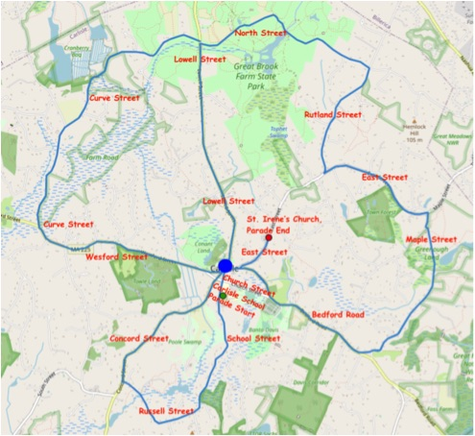

Available parking lots along the routes to watch from cars:
- Center Park
- Cranberry Bog Parking Lot
- Spalding Field Parking Lot
- Saint Irene’s Parking Lot
Please avoid parking at the Great Brook Park and ski parking lots for parade viewing. Given the recent snowfall, both lots will be crowded with x-country skiers’ cars.

